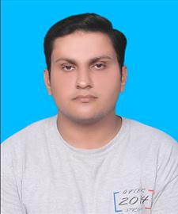
ZAID YOUSAF
Father Name: M YOUSAF MUGHAL
CNIC NO: 34301-1067872-5
Cell # 00-92-3063184141
Email:mughalzaidi@yahoo.com
Waniky road, street #, house # A_127, Hafizabad ,Pakistan

Career Objective

A Dynamic, Energetic, Hardworking& Experienced Professional, Wishing to focus on a challenging career at an organization, where Technical Skills & Experience will be making a significant contribution towards Corporate Goals

Experience and Training

- Attending a training session in Millat tractor

- Attending a workshop session on heavy and construction machines

Key skills

- Analytical Thinking, Ability to Learn & Result Oriented

- Team Leader, Flexible in all Aspects of Work

- Excellent Communication and Interpersonal Relations

Academic Qualification

- ∑ | - Bachelor in MECHANICAL ENGINEERING AND TECHNOLOGY
 | UNIVERSITY COLLEGE OF ENGINEERING AND TECHNOLOGY | 2012-2016
- ∑ | - FACULTY OF SCIENCE(F.s.c)
 | PUNJAB COLLEGE HAFIZABAD 2010-2012

Software Skills
Software(s) | Skill Level
Auto Cad 2D and 3D Mechanical Drawing | Expert
Operating Systems, Internet system | Expert
ENGNEERING DRAWING 2D_3D MANUAL | Expert
MASTER CAM Drafting | Expert
SOLID EDGE | Expert
ENGNEERING DRAWING 2D_3D MANUAL | Expert

